REPORT

Note to Self

Objective:

We all have secrets. Secret in mind is a burden. Sometimes we need a place to tell what's on mind frankly.

This is a blank place where you can express yourself and talk to yourself secretly. You can write anything as if you talk to yourself, and let them go.

Jot down ideas, take a memo, and take notes without decorated happiness or showing off. It will unburden yourself and you can feel better.

All thoughts, feelings and plans written down are archived as your own story. Only you can read them anytime later on.

FEAUTURES:

**1.Home page:**

The Home page that has Menu button if you touch it side menu navigation will open from left side. In that side menu user can traverse over the features of the **Note to Self**. Currently there are 3 features in Home page.

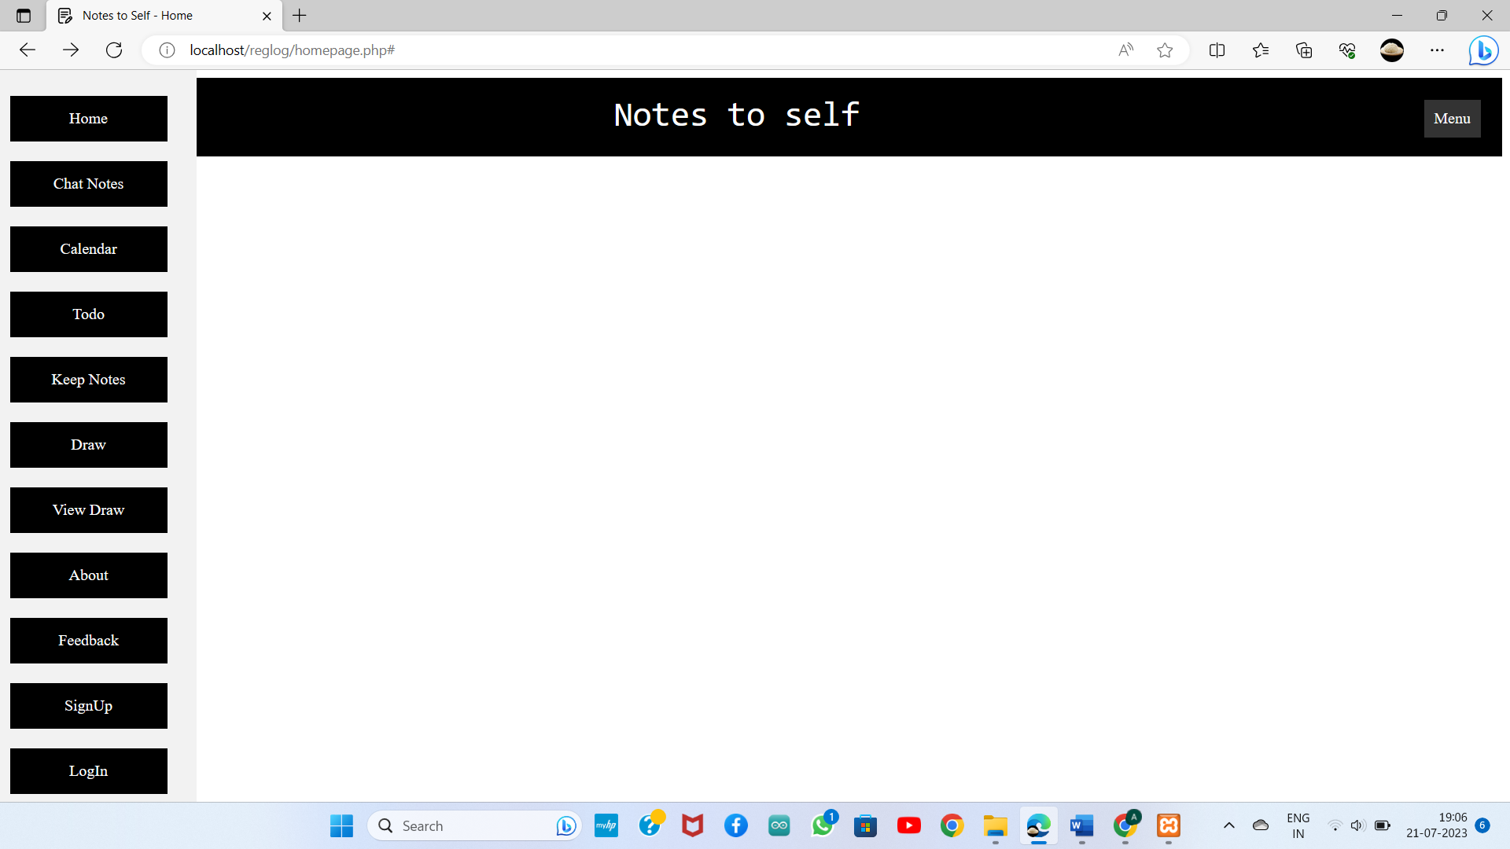

**2.Chat Notes:**

In chat interface that new notes button, by clicking New Notes

User can create Notes Title and Description of the notes.

By chat this chat interface user can type their Secrets

Send. User can create more notes title and send the

secrets. User can change the theme.

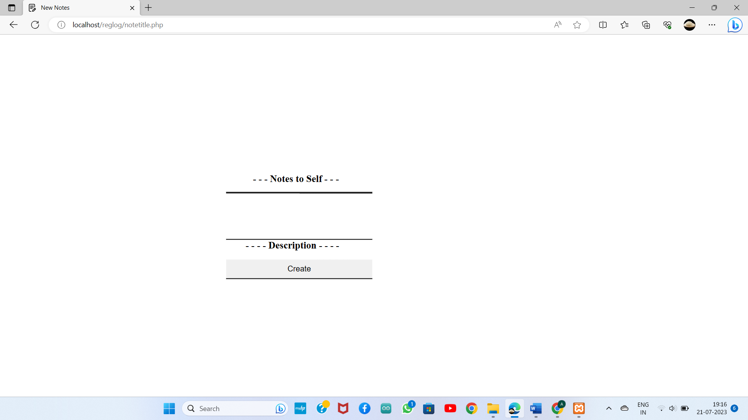

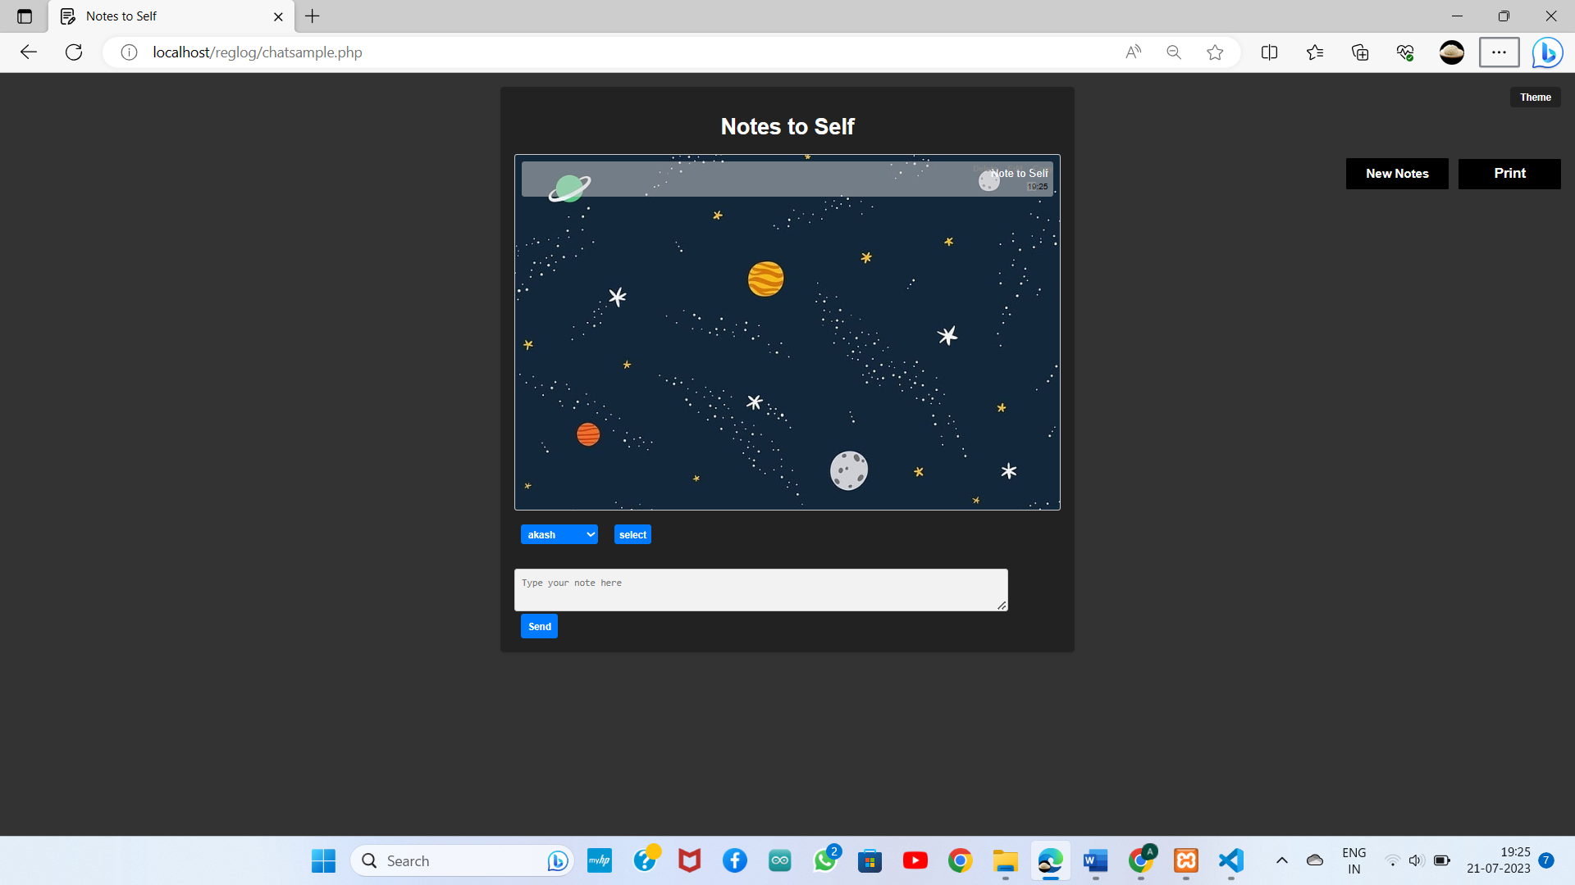

**Languages Used:**

1.HTML :

Hypertext Markup Language is used to create a webpage

2.CSS :

Cascading Style Sheets is used to give styles to webpage

3.JAVA SCRIPT :

JavaScript is used to create dynamically updating content, control multimedia, and pretty much everything else